

**TcHmi Merging how to guide**

**Document Purpose**  
This document is to be used as a guide to assist in understanding how to merge a TcHmi project into a PLC only project. There are a few reasons why this situation may come up. This document will attempt to give guidance on three of the most common scenarios seen to date.

Contents

Contents 2

Revision Log 3

Getting Started 4

Determine which Scenario you 5

Scenario 1. Merge in a known clean backup of TcHmi 5

Scenario 2. Working with an older TcHmi backup and what’s on the machine 9

Scenario 3. There is no backup of the TcHmi project just a working machine 12

Wrap up 13

# Revision Log

V20251010 - Initial document creation: (b.lekx-toniolo)

## Getting Started

So, instead of using a known clean backup copy, you went ahead and pulled from Target on a TcHmi based machine! Hey, these things happen, it’s just code, we can fix this!

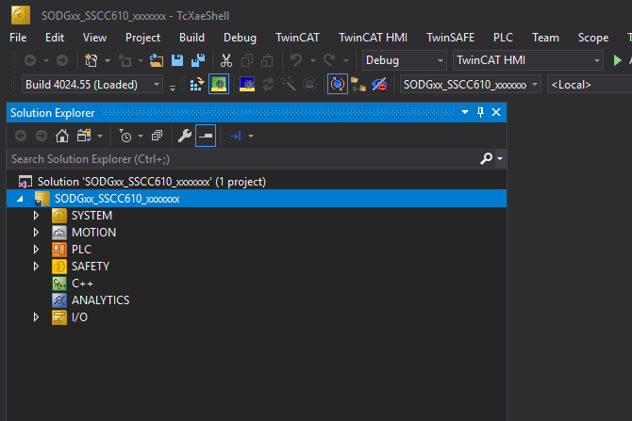If the above situation sounds familiar, this is what you should have:

Since you pulled from target you should be able to go online with the PLC without a download need. However, before we begin, it’s a good idea to verify this:

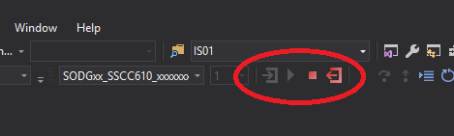

Great! So, at this point you know the PLC project is clean, now let’s move onto the TcHmi side of things.

## Determine which Scenario you have

The following examples cover three basic scenarios:

1. You have a known clean backup of your TcHmi project, you simply need to merge it back into the lone PLC project above
2. You have an older backup but believe work might exist ON the machine that is more recent
3. You have no known backup, you simply have what’s running on the machine

Select which scenario seems most appropriate and then follow the section below.

## Scenario 1. Merge in a known clean backup of TcHmi

Ensure XAE is closed.

From your clean backup, copy the entire ICxx folder from the backup:

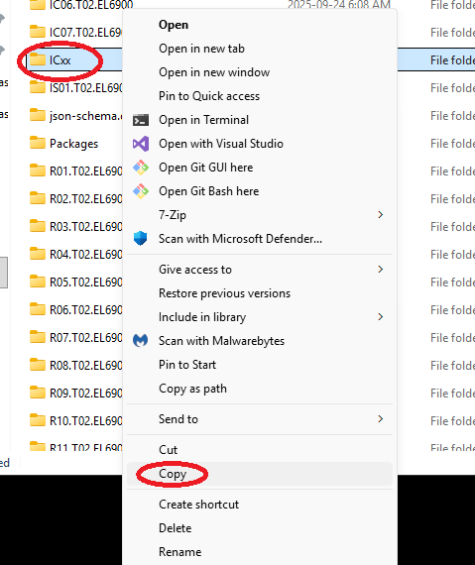

Now Paste this ICxx folder into the working area of your new PLC only solution, you have the right area if you see the solution file:

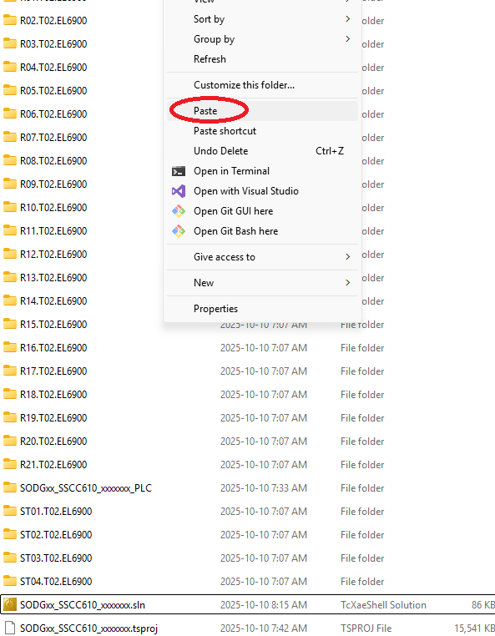

Now open the pulled from target plc project in XAE (grab a coffee as we all know this is not fast). When XAE is open, right click the solution and select “Add -> Existing Project”:

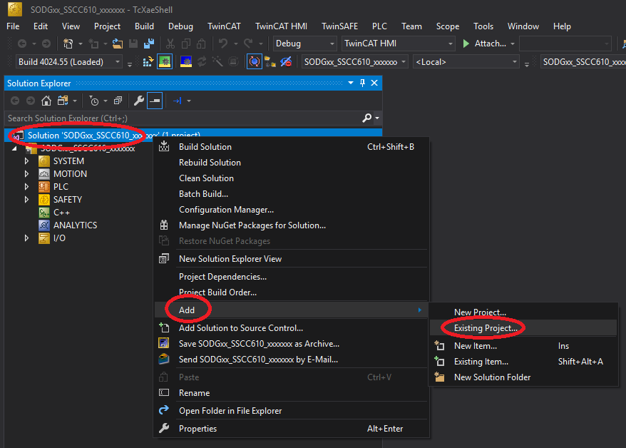

Navigate to the ICxx folder you just pasted into this solution’s working area and select the “ICxx.hmiproj” file, XAE will take a few mins to add in the project (hope that coffee is good):

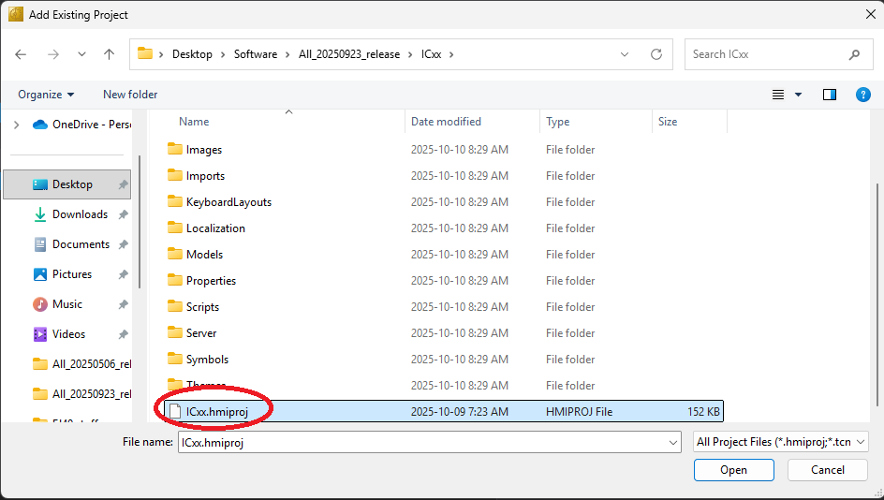

Once XAE is complete you should be left with a familiar sight, a solution that contains both the TcHmi and PLC projects:

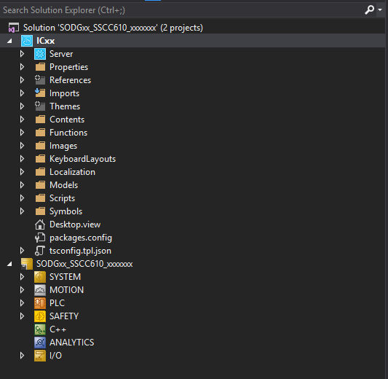

Once we hit this stage, it’s good idea to Rebuild the TcHmi project to ensure it came in AOK and to rebuild its internal references. After the first rebuild, confirm all server extensions are enabled and in good standing. If any of the server extensions are red, right click and select “Enable Extension”, wait for it to go green, once all server extensions are green then you should rebuild again. Once you have this all sorted out, you should end up with something like the following:

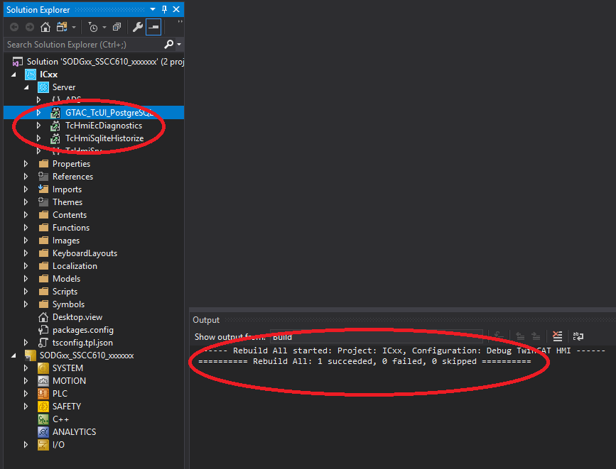

At this point, you now have a clean copy of the entire machine solution, containing both the PLC and TcHmi projects! Make a backup copy to a safe space and continue-on with your work.

## Scenario 2. Working with an older TcHmi backup and what’s on the machine

In this scenario we again start with our “pulled from target” lone PLC project but only have an older TcHmi backup. We know someone has worked on TcHmi, deployed to the machine but didn’t leave us a clean backup! Tisk tisk!

The good news, this scenario follows all the same merge procedure used in Scenario 1. Go ahead and perform the procedure in Scenario 1, except you will use the ICxx folder from the most recent backup copy you do have (even if it’s known to be out of date). Once that’s complete, we will add a few more steps below to grab the running copy files from the machine.

So, let’s assume we followed Scenario 1, used our most recent (yet out of date) backup of ICxx and are left this this point:

Close XAE.

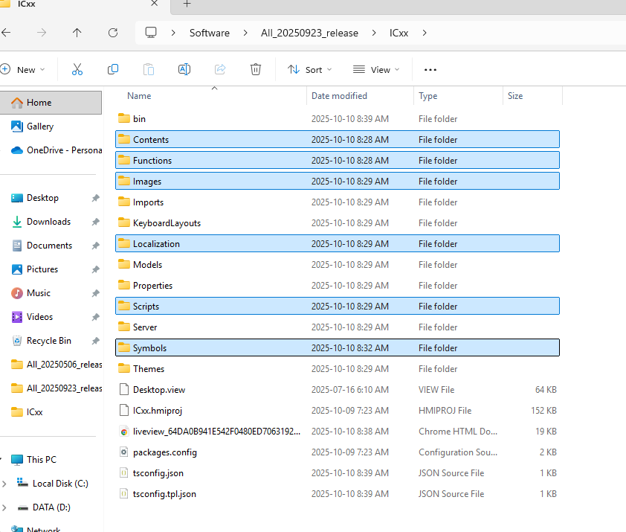In this newly created working area, navigate to the ICxx folder, locate the following folders and delete them:

Now VNC into the machine in question and navigate to:

C:\ProgramData\Beckhoff\TF2000 TwinCAT 3 HMI Server\service\TcHmiProject\www

Select the following folders (you’ll note they are the same folder names we just deleted from our working area above) and copy them:

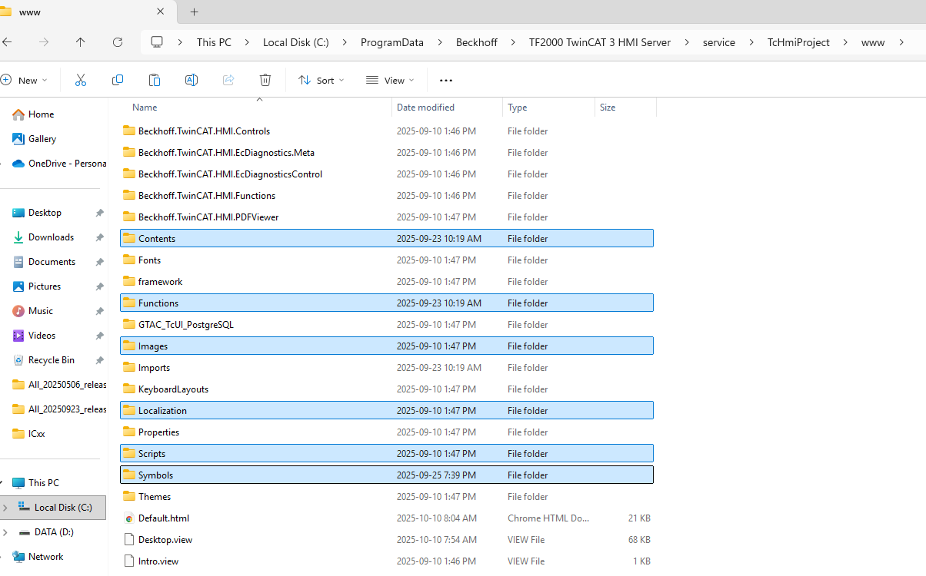

Paste these folders into your working area from above, this step essentially mimics a “pull from target” for the TcHmi portion of the machine.

Now, you should have all the latest work from the machine, minus Desktop.view. Desktop.view is generally not modified often after the initial deployment of the machine. IF, by chance, you suspect some work has been done to Desktop.view, then you can copy it from the machine www folder and paste into your working area as well.

Reopen XAE, rebuild your TcHmi project and carry on with your day as you should be complete!

## Scenario 3. There is no backup of the TcHmi project just a working machine

In this scenario we again start with our “pulled from target” lone PLC project but have no backup copy containing the TcHmi project.

In this scenario we will have to use a copy of the ICxx folder our framework. To avoid complications, we will want to select the major FW level (SSCC6.10 as example) that matches our machine, this information can be obtained by looking at the middle portion of the machine’s serial number:

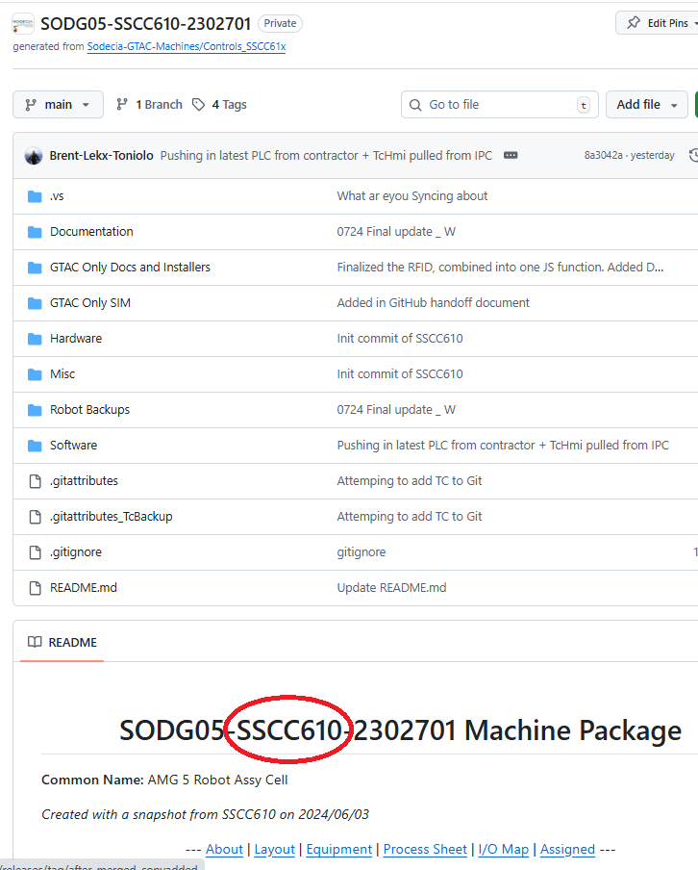

In the repo screen shot above we can see the project as created using FW major version SSCC6.10. Therefore, we \*\***should**\*\* be safe to use a copy of the ICxx folder from the FW SSCC610.

**\*\*Note\*\***

*There are rare scenarios where you should grab a copy of the framework that not only matches the FW major version but also more closely matches when the FW snapshot was taken to create the machine. The circumstances that dictate this are too complex to go into in this document. Generally, simply grab a copy of the latest FW to use for your ICxx folder source. Consult with a senior member of the development group if you suspect you need to more accurately pinpoint which build level of the FW should be taken instead. Each build level is stored in the FW repo under releases, so you can access older builds of the FW in question should the need arise. When all else fails, contact Brent.*

Once you obtain the correct FW copy, use it as your initial source for copy and pasting the ICxx folder into your working area.

Follow the steps in Scenario 2 (which also back tracks to Scenario 1) to get a copy of ICxx back merged in with your lone PLC. Then grab the latest TcHmi machine files from the actual machine and get them into your solution as well!

## Wrap up

Hopefully this document proved useful.

In all cases you will be doing a workaround outside of the expected general practices Beckhoff expected to see in their XAE + TcHmi products, so expect some abnormal behaviour (more so than the normal day to day XAE weirdness ha!).

A close / restart or full reboot of your PC can go a long way to reconciling general XAE crankiness.

Good luck……